**A Project Report On**

**AADHAAR BASED ONLINE VOTING SYSTEM**

Submitted in partial fulfillment of the requirements for award of the degree of

**BACHELOR OF TECHNOLOGY**

**In**

**COMPUTER SCIENCE AND ENGINEERING**

**By**

**P. GRACE SELINA (17P61A05D2)**

**REBBA DIKSHA (17P61A0F8)**

**P. SHARATHCHANDRIKA (17P61A05E2)**

**PENDEM NIHARIKA (17P61A05E5)**

**NIMMALA AJAY (17P61A05C9)**

**P. SAI HARSHA VARDHAN REDDY (17P61A05D9)**

**P. SAI TEJA VARDHAN REDDY (17P61A05D8)**

**Under the guidance of**

**N.S. SHEKAR BABU**

**INCHARGE CED**

**OF**

**ECIL-ECIT**

**ELECTRONICS CORPORATION OF INDIA LIMITED**

**(A Government of India Enterprise)**

**DEPARTMENT OF COMPUTER SCIENCE AND ENGINEERING**



**VIGNANA BHARATHI INSTITUTE OF TECHNOLOGY**

**ACKNOWLEDGEMENT**

We wish to take this opportunity to express our deep gratitude to all those who helped, encouraged, motivated and have extended their cooperation in various ways during our project work. It is our pleasure to acknowledgement the help of all those individuals who was responsible for foreseeing the successful completion of our project.

We would like to thank **N.S. SHEKAR BABU** (INCHARGE CED) and express our gratitude with great admiration and respect to our project guide **Mr. N. SURESH** for their help throughout the development of this project by providing us with required information without whose guidance, cooperation and encouragement, this project couldn’t have been materialized.

Last but not least, we would like to thank the entire respondents for extending their help in all circumstances.

**By**

**P. GRACE SELINA (17P61A05D2)**

**REBBA DIKSHA (17P61A0F8)**

**P. SHARATHCHANDRIKA (17P61A05E2)**

**PENDEM NIHARIKA (17P61A05E5)**

**NIMMALA AJAY (17P61A05C9)**

**P. SAI HARSHA VARDHAN REDDY (17P61A05D9)**

**P. SAI TEJA VARDHAN REDDY (17P61A05D8)**

**DECLARATION**

We hereby declare that the project entitled “**AADHAAR BASED ONLINE VOTING SYSTEM**”submitted in partial fulfillment of the requirements for the award of degree of Bachelor of Technology in Computer Science and Engineering. This dissertation is our original work and the project has not formed the basis for the award of any degree, associate ship, fellowship or any other similar titles and no part of it has been published or sent for the publication at the time of submission.

**By**

**P. GRACE SELINA (17P61A05D2)**

**REBBA DIKSHA (17P61A0F8)**

**P. SHARATHCHANDRIKA (17P61A05E2)**

**PENDEM NIHARIKA (17P61A05E5)**

**NIMMALA AJAY (17P61A05C9)**

**P. SAI HARSHA VARDHAN REDDY (17P61A05D9)**

**P. SAI TEJA VARDHAN REDDY (17P61A05D8)**

**TABLE OF CONTENTS**

**ABSTRACT**

**I. LIST OF FIGURES**

**1. INTRODUCTION**

**1.1 Motivation**

**1.2 Problem Definition**

**1.3 Scope of Project**

**1.4 User Classes and Characteristics**

**2.** LITERATURE SURVEY

**2.1 Introduction**

**2.2 Existing System**

**2.3 Proposed System**

**2.4 Modules**

**3. ANALYSIS**

**3.1 Introduction**

**3.2 Software Requirement Specification**

**3.3 User Interfaces**

**3.4 External Interface Requirements**

**3.4.1 Software Requirements**

**3.4.2 Hardware Requirements**

**3.5 Feasibility Study**

**3.5.1 Economic Feasibility**

**3.5.2 Operational Feasibility**

**3.5.3 Technical Feasibility**

**3.6 Java**

**3.7 Project Perspective**

3.8 Android

**3.8.1 About Native code**

**3.9 User Documentation**

3.9.1 Creating an android project

3.9.2 To create an AVD with the AVD manager

3.9.3 To Create or Modify a Launch Configuration

3.10 SQLite

**3.10.1 Design**

**3.10.2 Features**

**4. DESIGN**

**4.1 Introduction**

**4.2 Architecture Diagram**

**4.3 Unified Modeling Language (UML)**

**4.4 Building Blocks of UML**

**4.4.1 Things in the UML**

**4.4.2 Relational in the UML**

**4.4.3 Sequence Diagrams**

**4.5 UML diagrams**

**5. IMPLEMENTATION**

**5.1 Introduction**

**5.2 Design and Implementation Constraints**

**5.3 Screen Shots**

**6. TESTING AND VALIDATION**

**6.1 Software Testing**

**6.2 Testing Phases**

**6.3 Testing Activities**

**6.3.1 Unit Testing**

**6.3.2 Equivalence Testing**

**6.3.3 Integration Testing**

* 1. **Test Case Design**

**6.4.1 White-Box Testing**

**6.4.2 Black-Box Testing**

**7. CONCLUSIONS**

**8. REFERENCES**

**ABSTRACT**

**AADHAAR BASED ONLINE VOTING SYSTEM**

The project is mainly aimed at providing a secured and user-friendly Online Voting System. The problem of voting is still critical in terms of safety and security. This system deals with the design and development of a web based voting system using fingerprint and Aadhaar card in order to provide a high performance with high security to the voting system. The proposed Online Voting System allows the voters to scan their fingerprint, which is then matched with an already saved image within a database that is retrieved from Aadhaar card database of the government. The voting system is managed in a simpler way as all the users must login by Aadhaar card number and click on his/her favorable candidates to cast the vote By using biometric fingerprint it provides enough security which reduces the dummy votes.

# 1. INTRODUCTION

**1.1. MOTIVATION**

Online voting system is a way that helps public to select their representatives and express their preferences for how they will be governed. Naturally, the belief of the election process is utmost important. Election process has strong media coverage, particularly if something goes wrong. This system will increase the level of security and also the trust of voters. The problems of Maoist affected places for the voting has been addressed in while describe the genesis of Maoist violence and showed that public needs a more secure way of casting their vote. Online voting system definition given that Online voting systems offer advantages compared to other voting processes. It is hard to make the voting system trustworthy only because it has high security requirements: confidentiality and integrity.

**1.2. PROBLEM DEFINITION**

The problem of voting is still critical in terms of safety and security. ... The proposed Online Voting System allows the voters to vote using their registered aadhaar number which can be retrieved from aadhaar card database of the government.

**1.3. SCOPE OF PROJECT**

1. Increasing number of voters as individuals will find it easier and more convenient to vote.
2. Less effort and less labor intensive, as the primary cost and focus primary on creating, managing, and running a secure web voting portal.
3. The system can be used anytime and from anywhere by the Voters.
4. No one can cast votes on behalf of others and multiple times.
5. Saves time and reduces human intervention.
6. The system is flexible and secured to be used.
7. Unique Identification of voter through Aadhar number.
8. Improves voting with friendly Interface.
9. No fraud vote can be submitted.

**1.4. USER CLASSES AND CHARACTERISTICS**

In this users and executives get registered. This is a two-way communication where, the candidates who registered will be received by the Manager/Admin who then adds them to the Cast Vote Page. With this, the voters can know the details about the candidates participating from different parties.

1. **LITERATURE SURVEY**
   1. **INTRODUCTION**

In literature survey, we look into the details about the existing system and we try to reduce the disadvantages of the existing system. We try to improve the performance and the efficiency.

* 1. **EXISTING SYSTEM**

The Existing System of Election is running manually. The Voter has to Visit to Booths to Vote a Candidate so there is wastage of Time. The Voter has to manually register into the Voter List. Also Vote counting has to be done manually. All the Information of the Voter or Candidate is to be filling in manually. Voter must be present in his/her Constituency to give his/her Vote. There are Electronic Voting Machines used which Takes More Cost. The voting system previously being used by the Government is a paper based system, in which the voter simply picks up ballots sheets from electoral officials, tick off who they would like to vote for, and then cast their votes by merely handing over the ballot sheet back to electoral official. Some of the existing systems are: Paper-based voting: The voter gets a blank ballot and use a pen or a marker to indicate he want to vote for which candidate. Hand-counted ballots is a time and labour consuming process, but it is easy to manufacture paper ballots and the ballots can be retained for verifying, this type is still the most common way to vote. Lever voting machine: Lever machine is peculiar equipment, and each lever is assigned for a corresponding candidate. The voter pulls the lever to poll for his favourite candidate. This kind of voting machine can count up the ballots automatically. Because its interface is not user-friendly enough, giving some training to voters is necessary. Direct recording electronic voting machine: This type, which is abbreviated to DRE, integrates with keyboard; touch screen, or buttons for the voter press to poll. Some of them lay in voting records and counting the votes is very quickly. But the other DRE without keep voting records are doubted about its accuracy. Punch card: The voter uses metallic hole-punch to punch a hole on the blank ballot. It can count votes automatically, but if the voter’s perforation is incomplete, the result is probably determined wrongfully.

**2.3 PROPOSED SYSTEM**

The proposed system is the online voting system using aadhar card. It allows particular voter to cast the vote online and update the database in the server. The online voting system uses aadhaar card to retrieve the complete details about the voter.

**2.4 MODULES**

This application consists of following modules

* + - 1. Administrator
      2. Client

1. Administrator module

It refers to the system administrator who controls the entire voting system. Administrator is responsible for storing the information of the new voter; modify any voter’s information, deleting any voter’s information and also some operations related to candidate information. Administrator can see the results of the election process also.

2. Client module:

A computer program is used to contact and obtain data from a program on the server computer linked in the network. In our project the voter can cast the vote in the client computer and vote count of the particular candidate is updated in the server computer.

**3.AnalysiS**

* 1. **INTRODUCTION**

In this phase the requirements are gathered and analyzed. This phase is the main focus of the users and registered accounts. Meetings with users and registered people are held in order to determine the requirements like: Who is going to use the system? How will they use the system?  What data should be input into the system?  What data should be output by the system?  These are general questions that get answered during a requirements gathering phase. After requirement gathering these requirements are analyzed for their validity and the possibility of incorporating the requirements in the system to be development is also studied.

Finally, a Requirement Specification document is created which serves the purpose of guideline for the next phase of the model.

* 1. **SOFTWARE REQUIREMENT SPECIFICIFICATION**

The software requirements specification specifies the functional requirements and nonfunctional requirements. Functional requirements refers to how the system is going to react according to the input provided and how it is going to behave in particular situations and non-functional requirements refers to Usability, Reliability, Availability, Performance, Security, Supportability, Interface.

## 3.3 USER INTERFACES:

## This application include GUI standards or product family style guides that are to be followed, screen layout constraints, buttons and functions that will appear on every screen, error message display standards, and so on.

# 3.4 EXTERNAL INTERFACE REQUIREMENTS:

**3.4.1 SOFTWARE REQUIREMENTS**

Operating System: Windows 7

Technology: Java/J2EE (Servlets, JSP, JDBC)

Web Technologies: HTML, JavaScript, CSS

Web Server: Tomcat7.0

Database: Oracle10g Express Edition

Software: JDK1.6

**3.4.2 HARDWARE REQUIREMENTS**

Hardware: Pentium based System with a minimum of P4

RAM: 1GB (minimum)

### 3.5 FEASIBILITY STUDY

An important outcome of the preliminary investigation is the determination that system requested is feasible. This is to identify the objectives of a new system. Before solving a problem one must know what the problem is. The study is carried out by a small group of people who are familiar with system analysis and design process. Fact finding techniques are used to gather the required information.

The three major areas consider while determining the feasibility of the project are

1. Economic Feasibility
2. Operational Feasibility
3. Technical Feasibility

**3.5.1 ECONOMIC FEASIBILITY**

Economic feasibility attempts to weigh the costs of developing and implementing a new system, against the benefits that would accrue from having the new system in place. This feasibility study gives the top management the economic justification for the new system.

A simple economic analysis which gives the actual comparison of costs and benefits are much more meaningful in this case. These could include increased customer satisfaction, improvement in product quality better decision making timeliness of information, expediting activities, improved accuracy of operations, better documentation and record keeping, faster retrieval of information, better employee morale.

**3.5.2 OPERATIONAL FEASIBILITY**

Proposed projects are beneficial only if they can be turned into information systems that will meet the organizations operating requirements. Simply stated, this test of feasibility asks if the system will work when it is developed and installed. Are there major barriers to Implementation? Here are questions that will help test the operational feasibility of a project:

Is there sufficient support for the project from management from users? If the current system is well liked and used to the extent that persons will not be able to see reasons for change, there may be resistance.

Are the current business methods acceptable to the user? If they are not, Users may welcome a change that will bring about a more operational and useful systems.

Have the user been involved in the planning and development of the project?

Early involvement reduces the chances of resistance to the system and in general and increases the likelihood of successful project. Since the proposed system was to help reduce the hardships encountered. In the existing manual system, the new system was considered to be operational feasible.

**3.5.3 TECHNICAL FEASIBILITY**

Evaluating the technical feasibility is the trickiest part of a feasibility study. This is because, at this point in time, not too many-detailed design of the system, making it difficult to access issues like performance, costs on (on account of the kind of technology to be deployed) etc.

A number of issues have to be considered while doing a technical analysis.

i) Understand the different technologies involved in the proposed system:

Before commencing the project, we have to be very clear about what are the technologies that are to be required for the development of the new system.

ii) Find out whether the organization currently possesses the required technologies:

Is the required technology available with the organization?

If so is the capacity sufficient?

For instance -

“Will the current printer be able to handle the new reports and forms required for the new system?”

**3.6 JAVA**

Java is an object-oriented language, and is very similar to C++. Java is simplified to eliminate language features that cause common programming errors. Java source code files are compiled into a format called byte code, which can then be executed by a Java interpreter. Features being

1. **PLATFORM INDEPENDENT**

The programs written on one platform can run on any platform provided the platform must have the JVM.

1. **PORTABLE**

The feature Write-once-run-anywhere makes the java language portable provided that the system must have interpreter for the JVM.

1. **SIMPLE**

Programs are easy to write and debug because java does not use the pointers explicitly. It also has the automatic memory allocation and reallocation system.

1. **MULTITHREADED**

Multithreading means a single program having different threads executing independently at the same time.

1. **ROBUST**

Java has the strong memory allocation and automatic garbage collection mechanism. It provides the powerful exception handling and type checking mechanism as compare to other programming languages.

1. **OBJECT ORIENTED**

To be an Object Oriented language, any language must follow at least the four characteristics.

* Inheritance
* Encapsulation
* Polymorphism
* Dynamic binding

1. **DISTRIBUTED**

The widely used protocols like HTTP and FTP are developed in java. Internet programmers can call functions on these protocols and can get access to the files from any remote machine on the internet rather than writing codes on their local system.

1. **SECURE**

All the programs in java run under an area known as the sand box. Security manager determines the accessibility options of a class like reading and writing a file to the local disk.

1. **HIGH PERFORMANCE**

In the beginning interpretation of byte code resulted in slow performance but the advance version of JVM uses the adaptive and just in time compilation technique that improves the performance.

1. **INTEGRATED**

Java is an interpreted language as well. Programs run directly from the source code. 

## 3.7. PROJECT PERSPECTIVE

Android is a software stack for mobile devices that includes an operating system, middleware and key applications. The [Android SDK](http://developer.android.com/sdk/index.html) provides the tools and APIs necessary to begin developing applications on the Android platform using the Java programming language.

The Android SDK includes a comprehensive set of development tools. Requirements include Java Development Kit, the officially supported integrated development environment (IDE) is Android Studio using the Android Development Tools (ADT) Plug in, though developers may use any text editor to edit Java and XML files then use command line tools to create, build and debug Android applications. It would be more cost effective if we can use normal phone numbers for receiving data from customers via SMS. However it is a very tedious process if we don’t have backend automated system to analyze the received data. We are proposing the below approach to make this process cost effective as well as efficient.

**3.8. ANDROID**

Android is a software stack for mobile devices that includes an operating system, middleware and key applications. The android SDK provides the tools and APIs necessary to begin developing applications on the Android platform using the Java programming language.

The Android SDK includes a comprehensive set of development tools. These include a debugger, libraries, a handset emulator (based on QEMU), documentation, sample code, and tutorials. Currently supported development platforms include x86-architecture computers running Linux (any modern desktop Linux distribution), Mac OS X 10.4.8 or later, Windows XP or Vista. The officially supported integrated development environment (IDE) is Android Studio using the Android Development Tools (ADT) Plugin, though developers may use any text editor to edit Java and XML files then use command line tools to create, build and debug Android applications.

**3.8.1 ABOUT NATIVE CODE**:

Libraries written in C and other languages can be compiled to ARM native code and installed, but the Native Development Kit is not yet officially supported by Google. Native classes can be called from Java code running under the Dalvik VM using the System. Load Library call, which is part of the standard Android Java classes.

## 3.9. USER DOCUMENTATION

In this user manual we are going to keep the information regarding our product, which can be understandable by a new person who is going to use it. If a new person is using it, online help will be provided in that. We are going to explain each and every step clearly about our product so that any user can easily understand it.

**3.9.1. CREATING AN ANDROID PROJECT**

The ADT plug-in provides a New Project Wizard that you can use to quickly create a new Android project (or a project from existing code). To create a new project:

* Select File > New > Project.
* Select Android > Android Project, and click Next.
* Select the contents for the project:
* Enter a Project Name. This will be the name of the folder where your project is created.
* Under Contents, select Create new project in workspace. Select your project workspace location.
* Under Target, select an Android target to be used as the project's Build Target. The Build Target specifies which Android platform you'd like your application built against.
* Unless you know that you'll be using new APIs introduced in the latest SDK, you should select a target with the lowest platform version possible, such as Android 1.1.
* Under Properties, fill in all necessary fields:

Enter an Application name. This is the human-readable title for your application — the name that will appear on the Android device.

1. Enter a Package name. This is the package namespace (following the same rules as for packages in the Java programming language) where all your source code will reside.
2. Select Create Activity (optional, of course, but common) and enter a name for your main Activity class.
3. Enter a minimum SDK Version. This is an integer that indicates the minimum API Level required to properly run your application. Entering this here automatically sets the minimum SDK Version attribute in the [<uses-sdk>](http://developer.android.com/guide/topics/manifest/uses-sdk-element.html) of your Android Manifest file. If you're unsure of the appropriate API Level to use, copy the API Level listed for the Build Target you selected in the Target tab.
4. Click Finish.

**3.9.2. TO CREATE AN AVD WITH THE AVD MANAGER:**

* Select Window > Android SDK and AVD Manager, or click the Android SDK and AVD Manager icon (a black device) in the Eclipse toolbar.
* In the Virtual Devices panel, you'll see a list of existing AVDs. Click New to create a new AVD.
* Fill in the details for the AVD.
* Give it a name, a platform target, an SD card image (optional), and a skin (HVGA is default).
* Click Create AVD.

When you first run a project as an Android Application, ADT will automatically create a run configuration. The default run configuration will launch the default project Activity and use automatic target mode for device selection (with no preferred AVD).

**3.9.3. TO CREATE OR MODIFY A LAUNCH CONFIGURATION**

Follow these steps as appropriate for your Eclipse version:

* Open the run configuration manager.
* In Eclipse 3.3 ,select Run > Open Run Dialog (or Open Debug Dialog)
* In Eclipse 3.4 (Ganymede), select Run > Run Configurations (or Debug Configurations)
* Expand the Android Application item and create a new configuration or open an existing one.

**3.10. SQLITE**

**SQLite** is an ACID-compliant [embedded](http://en.wikipedia.org/wiki/Embedded_database) [relational database management system](http://en.wikipedia.org/wiki/Relational_database_management_system) contained in a relatively small C programming library. The source code for SQLite is in the public domain.

**3.10.1. DESIGN**

Unlike client-server database management systems, the SQLite engine is not a standalone process with which the application program communicates. Instead, the SQLite [library](http://en.wikipedia.org/wiki/Library_%28computing%29) is linked in and thus becomes an integral part of the application program. The library can also be called dynamically. The application program uses SQLite's functionality through simple SMS, which reduces [latency](http://en.wikipedia.org/wiki/Latency_%28engineering%29) in database access as function SMS within a single process are more efficient than [inter-process communication](http://en.wikipedia.org/wiki/Inter-process_communication).

**3.10.2. FEATURES**

SQLite implements most of the [SQL-92](http://en.wikipedia.org/wiki/SQL-92) standard for [SQL](http://en.wikipedia.org/wiki/SQL) but it lacks some features. A standalone program called sqlite3 is provided which can be used to create a database, define tables within it, insert and change rows, run queries and manage a SQLite database file. SQLite is a popular choice for local/client SQL storage within a [web browser](http://en.wikipedia.org/wiki/Web_browser) and within a [rich internet application framework](http://en.wikipedia.org/wiki/List_of_rich_internet_application_frameworks). This may be because SQLite's dynamically typed storage matches the [web browser](http://en.wikipedia.org/wiki/Web_browser)'s core languages of [JavaScript](http://en.wikipedia.org/wiki/Javascript) and [XML](http://en.wikipedia.org/wiki/XML). SQLite uses an unusual [type system](http://en.wikipedia.org/wiki/Type_system) for an SQL-compatible DBMS. Instead of assigning a type to a column as in most SQL database systems, types are assigned to individual values; in language terms it is dynamically typed.

**4.DESIGN**

**4.1. INTRODUCTION**

Software design is the process by which an agent creates a specification of a software artifact, intended to accomplish goals, using a set of primitive components and subject to constraints. Software design may refer to either "all the activity involved in conceptualizing, framing, implementing, commissioning, and ultimately modifying complex systems" or "the activity following requirements specification and before programming, as in a stylized software engineering process." Software design usually involves problem solving and planning a software solution. This includes both a low-level component design and a high-level, architecture design.

**4.2. ARCHITECTURE DIAGRAM**

Architecture diagram is a [diagram](http://en.wikipedia.org/wiki/Diagram) of a [system](http://en.wikipedia.org/wiki/System), in which the principal parts or functions are represented by blocks connected by lines that show the relationships of the blocks. The block diagram is typically used for a higher level, less detailed description aimed more at understanding the overall concepts and less at understanding the details of implementation.

SMS

User

Android SDK

SQLite

Java program

Get

CSV file

**Fig 4.2 Architecture**

A SMS user for who the application looks like an user interface actually consists of a database called as SQLite that comes along with Android SDK and need no other installation. This is the database that is used to store and retrieve information. This is an application that is developed in java and hence all its features apply here as well such as platform independence, data hiding,

**4.3. UNIFIED MODELING LANGUAGE (UML)**

The unified modeling is a standard language for specifying, visualizing, constructing and documenting the system and its components is a graphical language which provides a vocabulary and set of semantics and rules. The UML focuses on the conceptual and physical representation of the system. It captures the decisions and understandings about systems that must be constructed. It is used to understand, design, configure and control information about the systems.

Depending on the development culture, some of these artifacts are treated more or less formally than others. Such artifacts are not only the deliverables of a project; they are also critical in controlling, measuring, and communicating about a system during its development and after its deployment.

The UML addresses the documentation of a system's architecture and all of its details. The UML also provides a language for expressing requirements and for tests. Finally, the UML provides a language for modeling the activities of project planning and release management.

**4.4. BUILINDING BLOCKS OF UML**

The vocabulary of the UML encompasses three kinds of building blocks:

1. Things
2. Relationships
3. Diagrams

Things are the abstractions that are first-class citizens in a model, relationships tie these things together and diagrams group interesting collections of things.

**4.4.1. THINGS IN THE UML**

There are four kinds of things in the UML:

1. Structural things
2. Behavioral things

**1. STUCTURALTHINGS:** are the nouns of UML models. The structural things used in the project design are:

First, a **class** is a description of a set of objects that share the same attributes, operations, relationships and semantics.

|  |
| --- |
| Window |
| Origin  Size |
| open()  close()  move()  display() |

##### **Fig: Classes**

Second, a **use case** is a description of set of sequence of actions that a system performs that yields an observable result of value to particular actor.

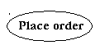

**Fig: Use Cases**

Third, a node is a physical element that exists at runtime and represents a computational resource, generally having at least some memory and often processing capability.

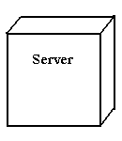

Fig: Nodes

**2. BEHAVIORAL THINGS:** are the dynamic parts of UML models. The behavioral thing used is:

**INTERACTION:**

An interaction is a behavior that comprises a set of messages exchanged among a set of objects within a particular context to accomplish a specific purpose. An interaction involves a number of other elements, including messages, action sequences (the behavior invoked by a message, and links (the connection between objects).



**Fig: Messages**

**4.4.2. RELATIONAL IN THE UML**

There are four kinds of relationships in the UML:

* Dependency
* Association
* Generalization
* Realization

A **dependency** is a semantic relationship between two things in which a change to one thing may affect the semantics of the other thing (the dependent thing).



**Fig: Dependencies**

An **association** is a structural relationship that describes a set links, a link being a connection among objects. Aggregation is a special kind of association, representing a structural relationship between a whole and its parts.



**Fig: Association**

A **generalization** is a specialization/ generalization relationship in which objects of the specialized element (the child) are substitutable for objects of the generalized element(the parent).



**Fig: Generalization**

A **realization** is a semantic relationship between classifiers, where in one classifier specifies a contract that another classifier guarantees to carry out.



Fig: Realization

**4.4.3. SEQUENCE DIAGRAMS**

UML sequence diagrams are used to represent the flow of messages, events and actions between the objects or components of a system. Time is represented in the vertical direction showing the sequence of interactions of the header elements, which are displayed horizontally at the top of the diagram.

Sequence Diagrams are used primarily to design, document and validate the architecture, interfaces and logic of the system by describing the sequence of actions that need to be performed to complete a task or scenario. UML sequence diagrams are useful design tools because they provide a dynamic view of the system behavior which can be difficult to extract from static diagrams or specifications.

**ACTOR**

Represents an external person or entity that interacts with the system

**Sequence diagram actor element**

**OBJECT**

Represents an object in the system or one of its components

**Sequence diagram object element**

**UNIT**

Represents a subsystem, component, unit, or other logical entity in the system (may or may not be implemented by objects)

**Sequence diagram unit element**

**SEPERATOR**

Represents an interface or boundary between subsystems, components or units (e.g., air interface, Internet, network)

**Sequence diagram separator element**

**GROUP**

Groups related header elements into subsystems or components

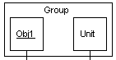

## 4.4.3.1. SEQUENCE DIAGRAM BODY ELEMENTS

**ACTION**

Represents an action taken by an actor, object or unit

**Sequence diagram action element**

**ASYNCHRONUS MESSAGE**

An asynchronous message between header elements

**Sequence diagram asynchronous message element**

**BLOCK**

A block representing a loop or conditional for a particular header element

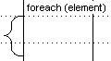

**CALL MESSAGE**

A call (procedure) message between header elements

**Sequence diagram call message element**

**CREATE MESSAGE**

A "create" message that creates a header element (represented by lifeline going from dashed to solid pattern)

**Sequence diagram create message element**

**DIAGRAM LINK**

Represents a portion of a diagram treated as a functional block. Similar to a procedure or function call that abstracts functionality or details not shown at this level and can be an optional link to another diagram for elaboration.

**Sequence diagram diagram link element**

Else Block Represents an "else" block portion of a diagram block

**Sequence diagram else block element**

**MESSAGE**

A simple message between header elements

**Sequence diagram message element**

**RETURN MESSAGE**

A return message between header elements

**Sequence diagram return message element**

**4.5. UML DIAGRAMS FOR AADHAAR BASED ONLINE VOTING SYSTEM**

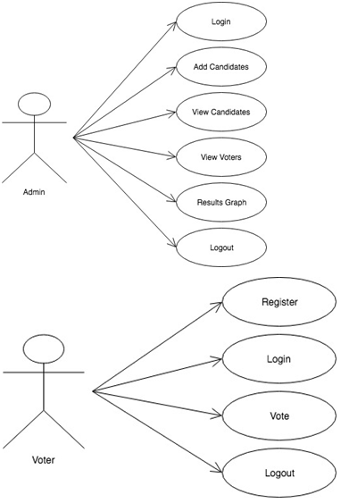

**SEQUENCE DIAGRAM**

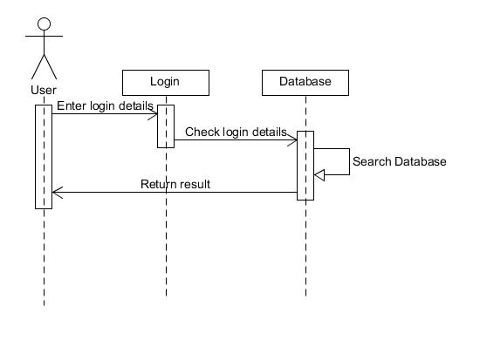

**Sequence Diagram**

**5.IMPLEMENTATION**

**5.1. INTRODUCTION**

Implementation is the most crucial stage in achieving a successful system and giving the user’s confidence that the new system is workable and effective. Implementation of the modified application to replace an existing one. This type of conversation is relatively easy to handle, provide there are no major changes in the system.

Each program is tested individually at the time of development using the data and has verified that this program linked together in the way specified in the programs specification, the computer system and its environment is tested to the satisfaction of the user. The system that has been developed is accepted and proved to be satisfactory for the user. And so the system is going to be implemented very soon. A simple operating procedure is included so that the user can understand the different functions clearly and quickly.

Initially as a first step the executable form of the application is to be created and loaded in the common server machine which is accessible to all the user and the server is to be connected to a network. The final stage is to document the entire system which provides components and the operating procedures of the system.

## 5.2. DESIGN AND IMPLEMENTATION CONSTRAINTS

All modules are coded thoroughly based on requirements from software organization. The software is designed in such a way that the user can easily interact with the screen. Software is designed in such a way that it can be extended to the real time business*.*

**5.3. SCREEN SHOTS**

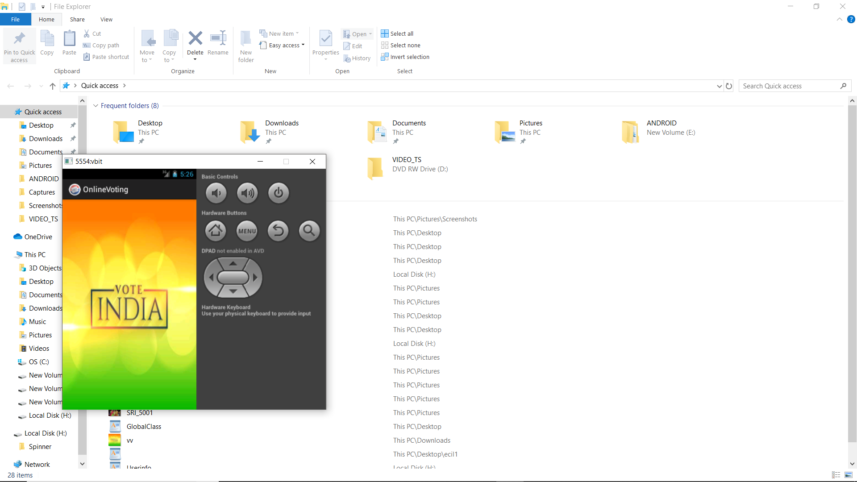

**Fig 1: Main Page**

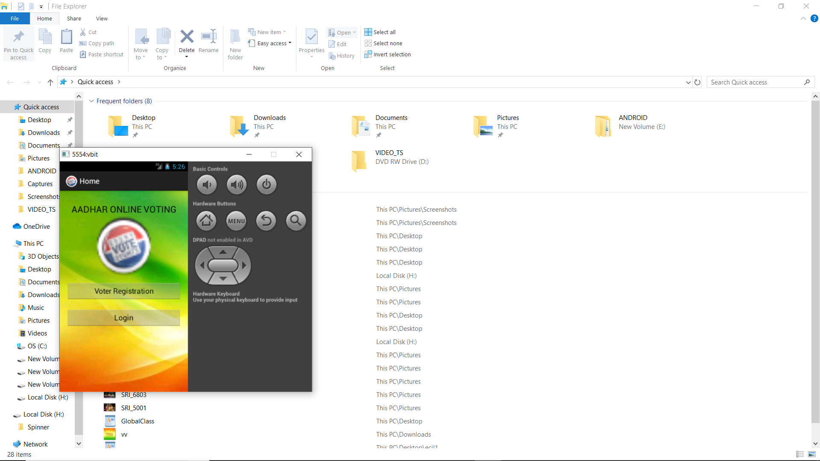

**Fig 2: Home Page**

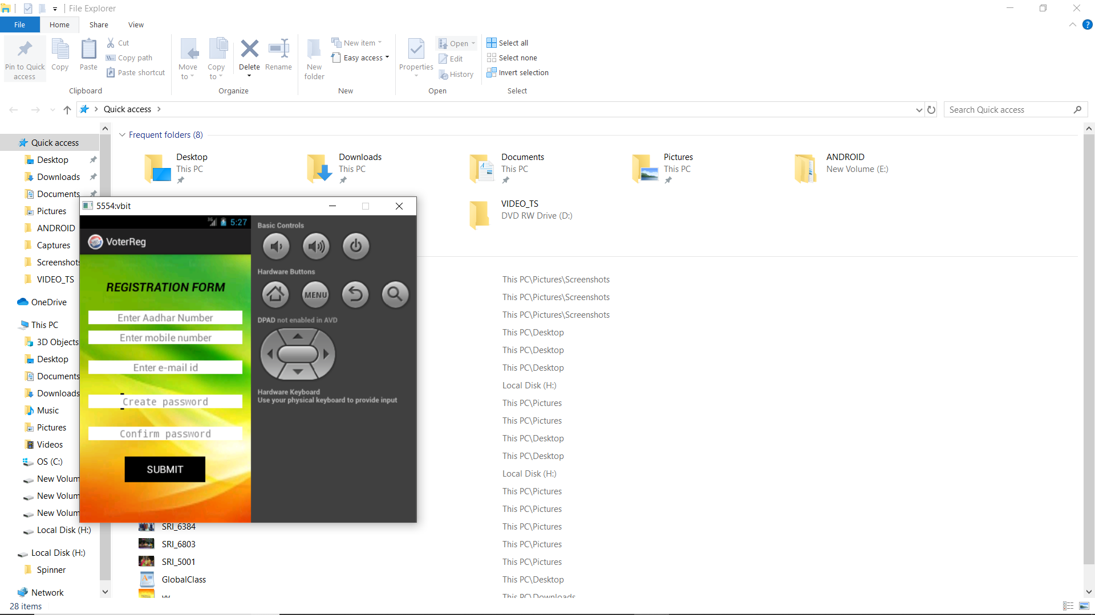

Fig 3: Voter Registration Page

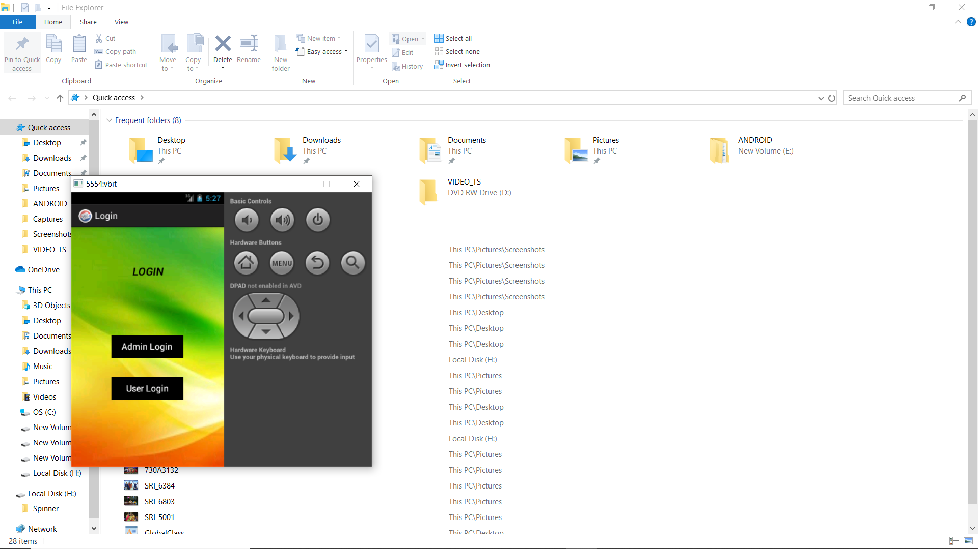

Fig 4: Login Page

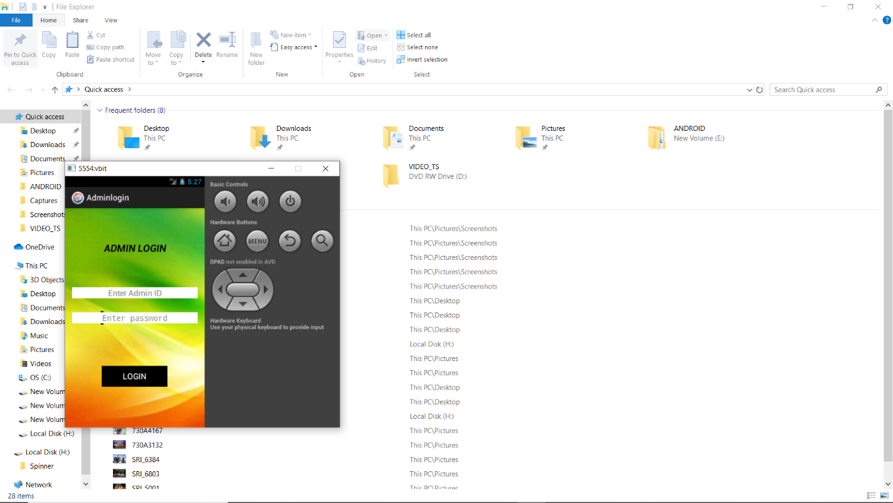

Fig 5: Admin Login Page

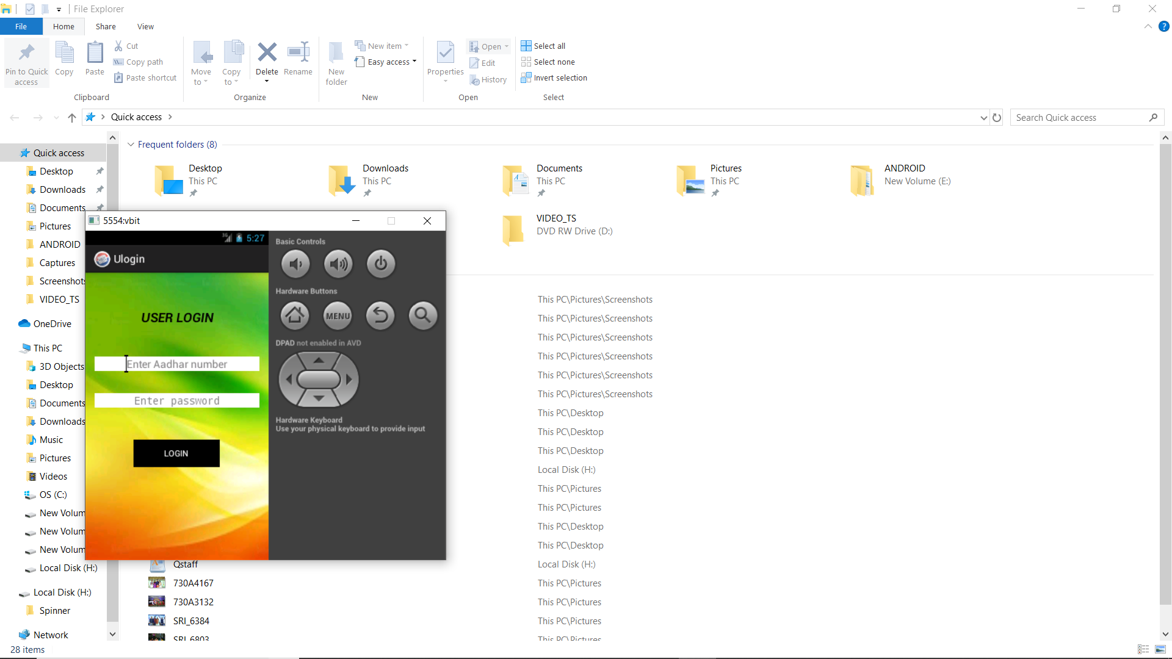

Fig 6: User Login Page

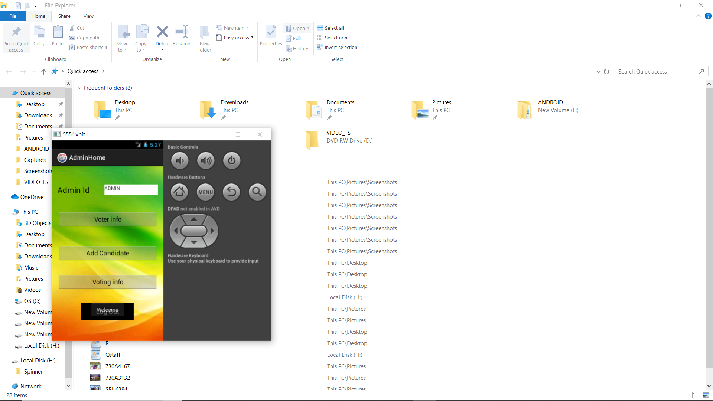

Fig 7: Admin Home Page

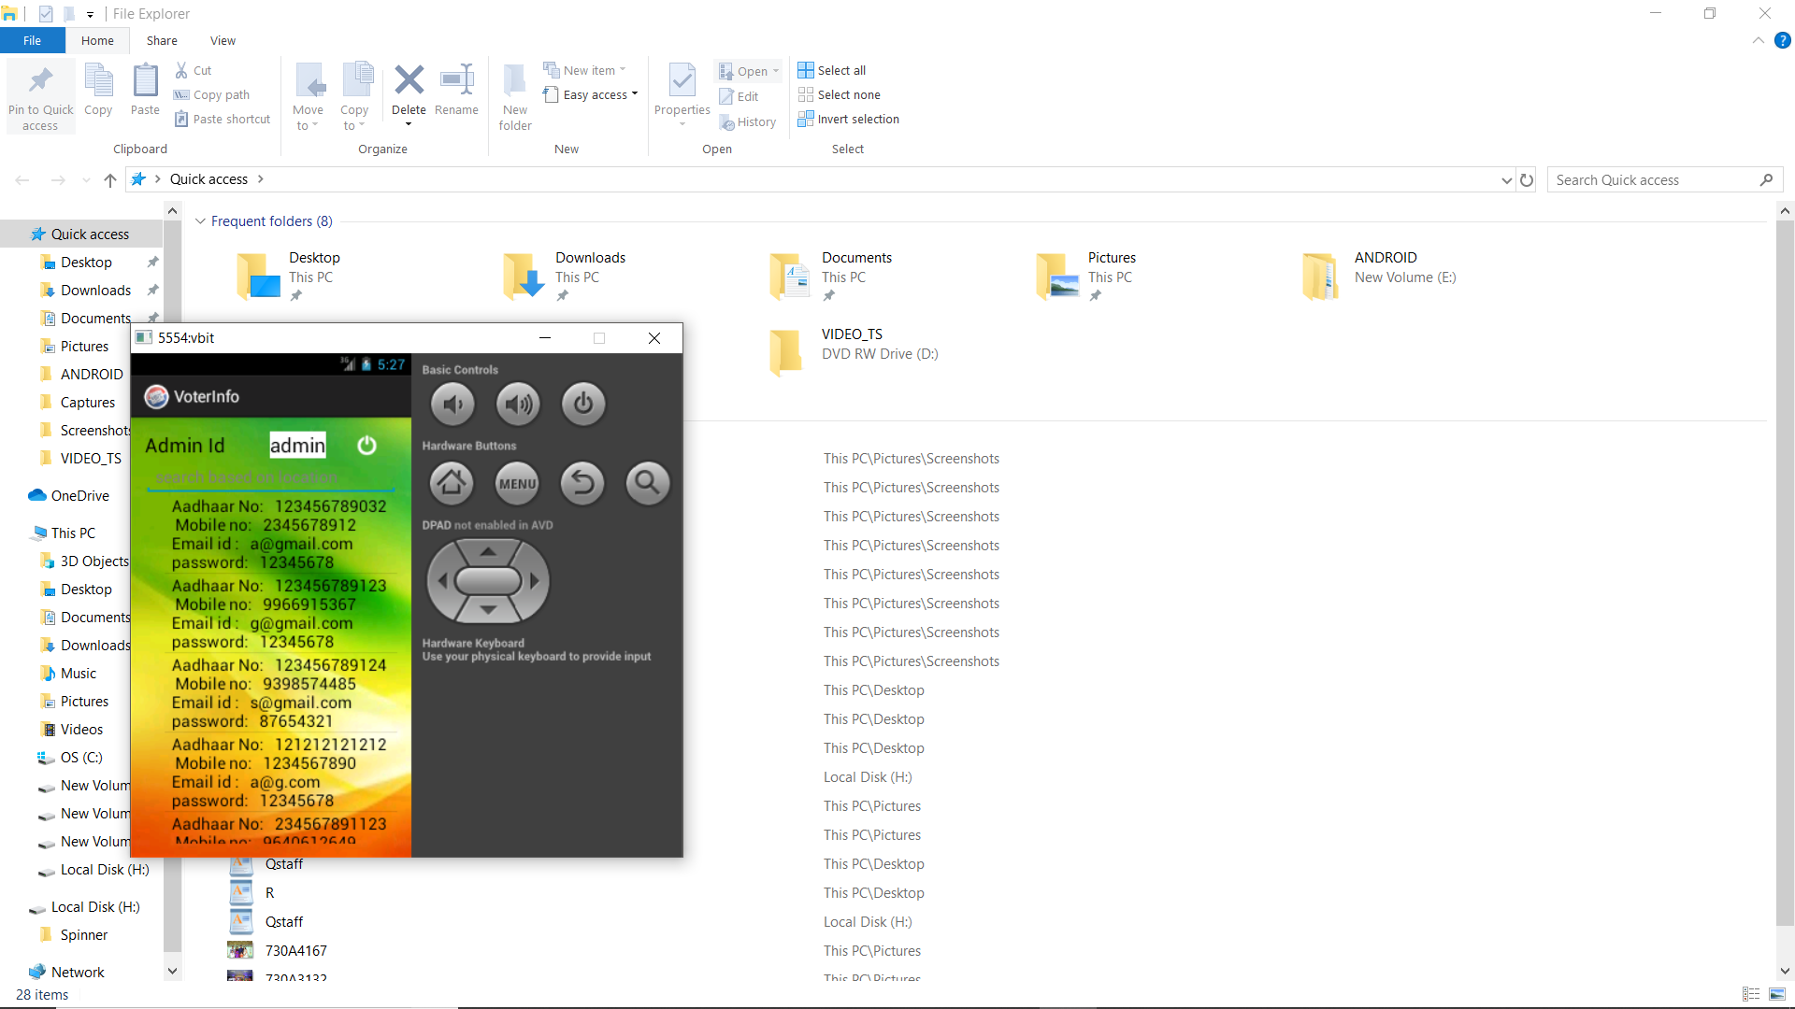

Fig:8 Voter info Page

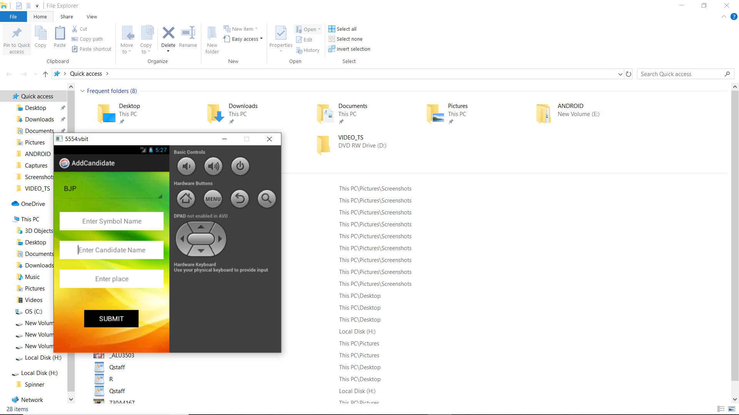

Fig 9: Candidate Registration Page

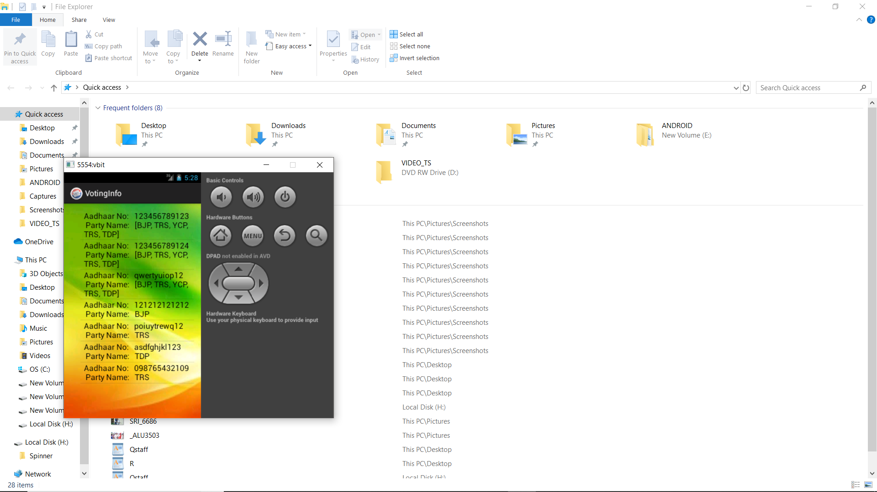

Fig 10: Voting Info Page

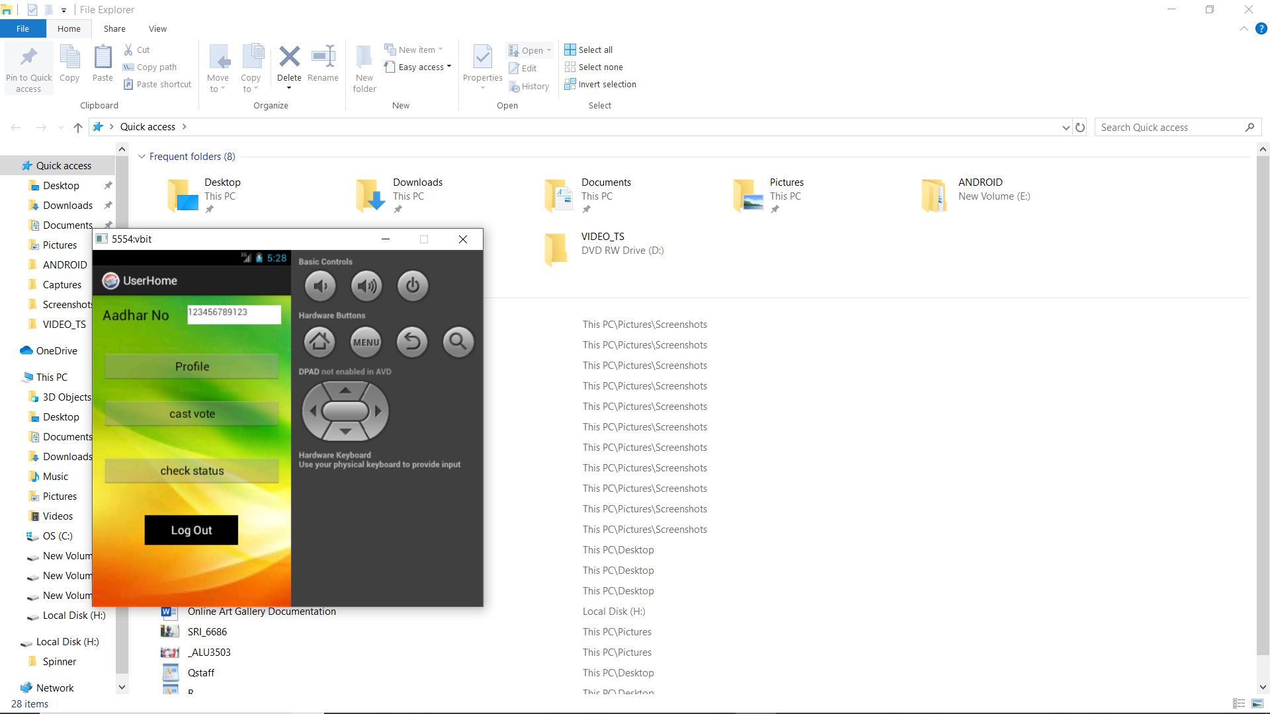

Fig 11: User Home Page

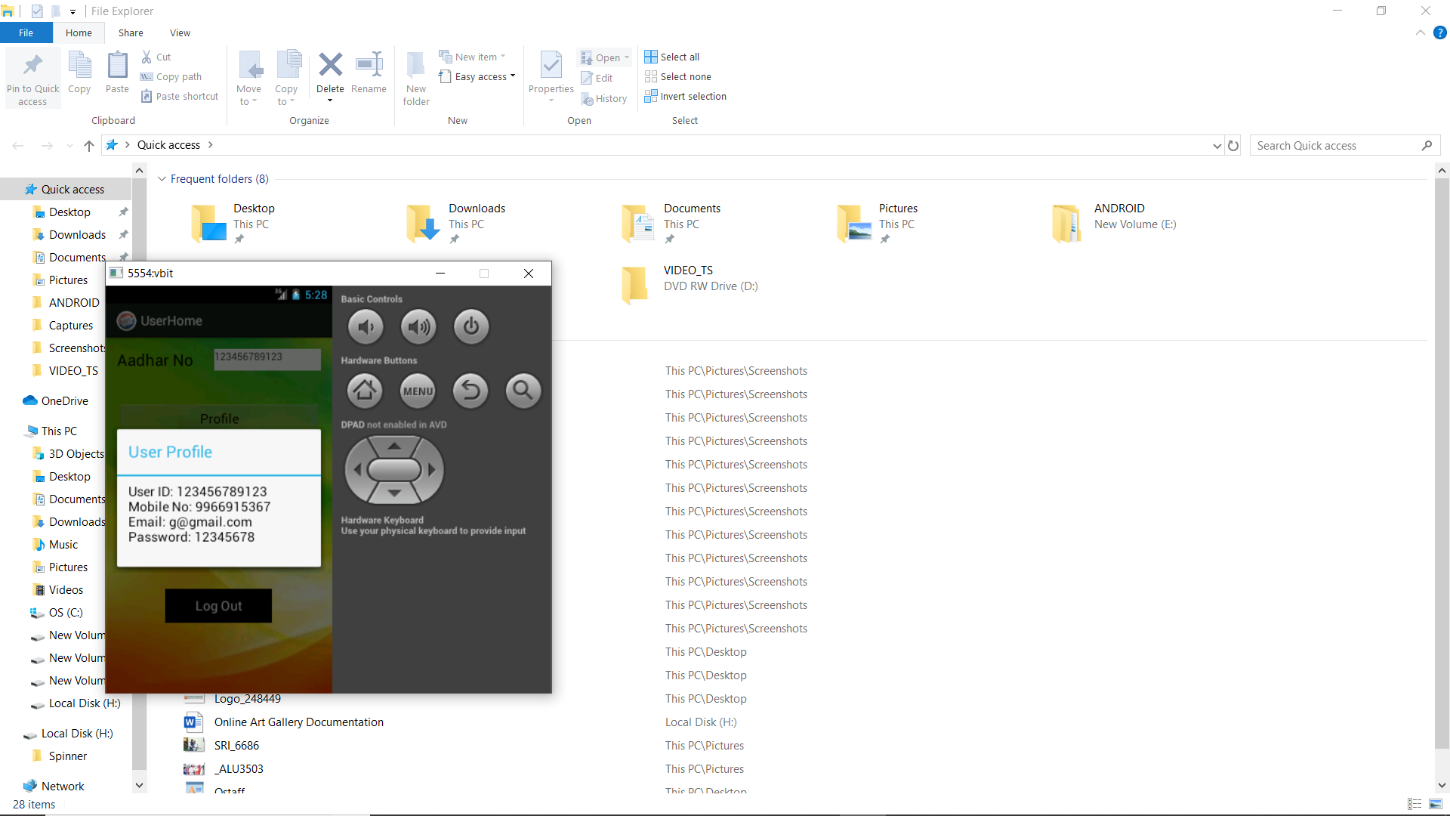

Fig 12: User profile

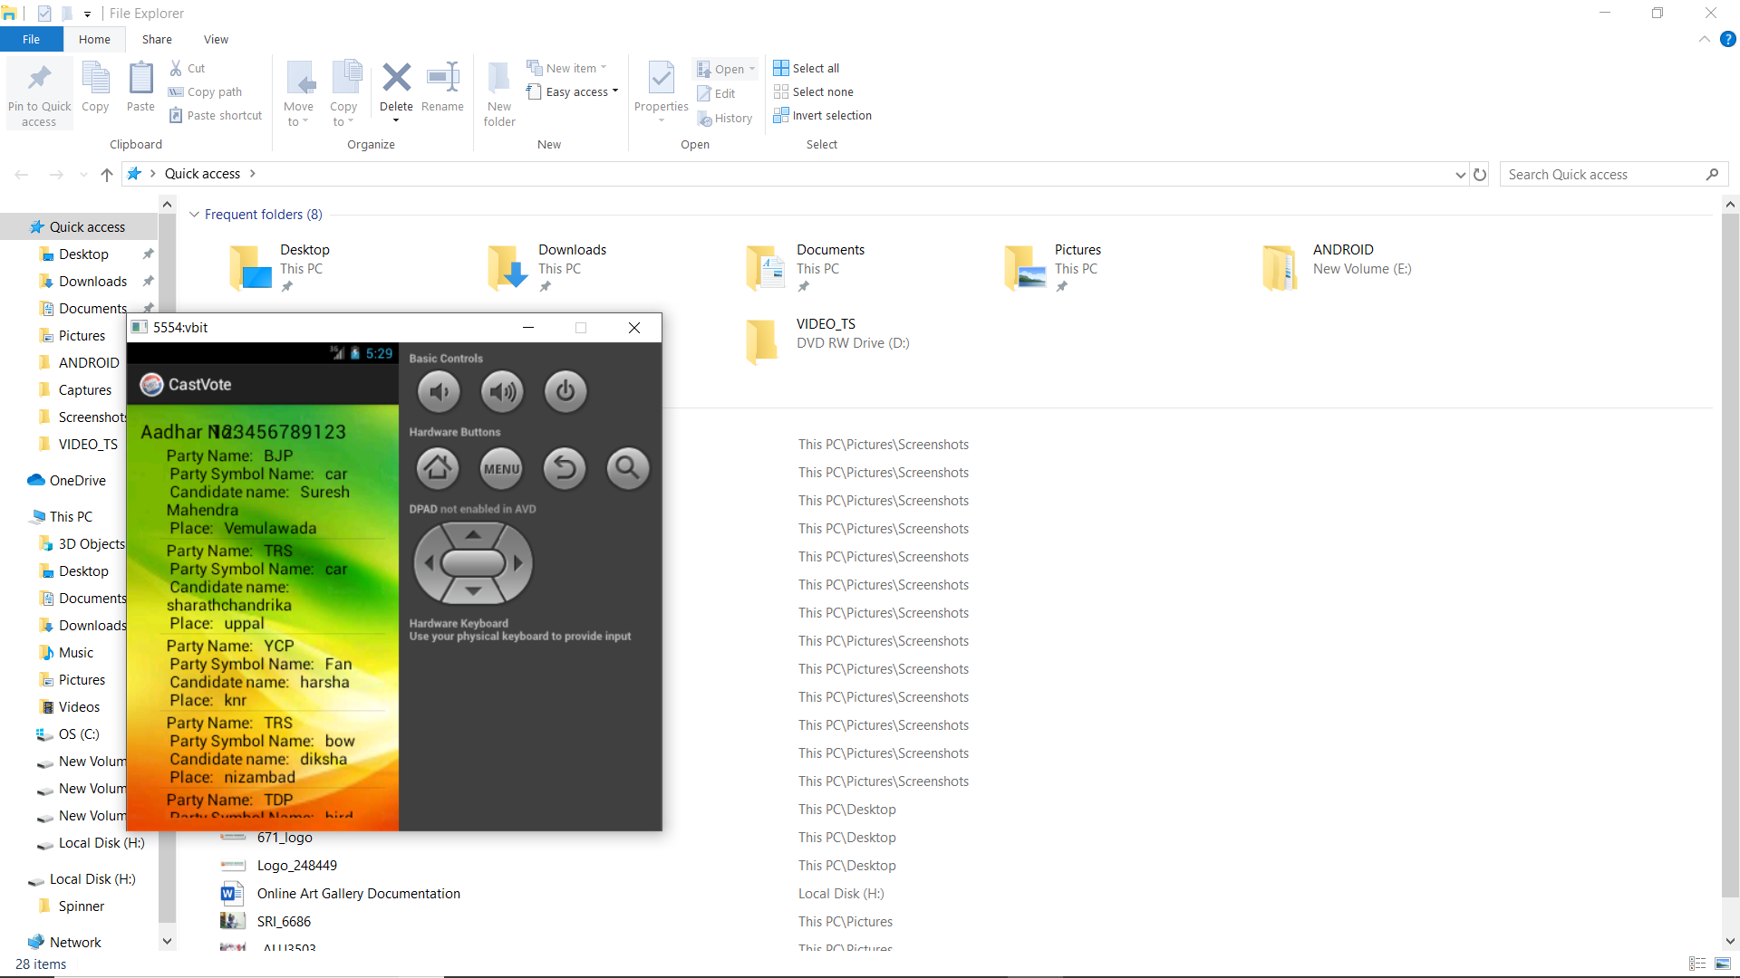

Fig 13: Cast Vote Page

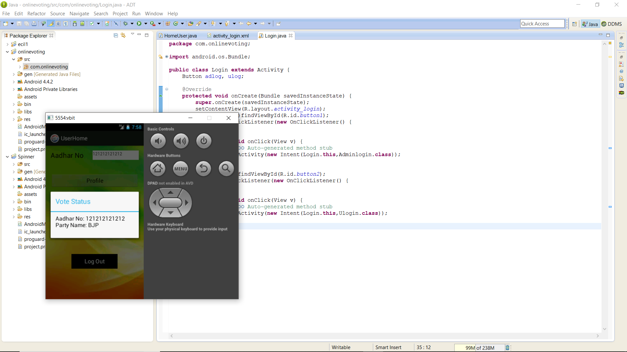

Fig 14: Vote Status

**6. TESTING**

## 6.1. SOFTWARE TESTING

Software testing is a critical element of software quality and assurance and represents ultimate review of specifications, design and coding. Testing is an exposure of the system to trial input to see whether it produces correct output.

## 6.2. TESTING PHASES

Software testing includes the following:

1. Test activities are determined and test data selected

2. The test is conducted and test results are compared with the expected results.

## 6.3. TESTING ACTIVITIES

1. INSPECTING COMPONENTS: This finds faults in the individual component through the manual inspection of its source code.
2. UNIT TESTING: This find faults by isolating an individual component using test stubs and drivers and by exercising the components using a test case.
3. INTEGRATION TESTING: This finds faults by integrating several components together. System testing, which focuses on the complete system, its functional and non-functional requirements and its target environment.

## 6.3.1. UNIT TESTING

Unit testing focuses on the building blocks of the software system, that is, objects and subsystems. They are three motivations behind focusing on components. First, unit testing reduces the complexity of the overall test activities, allowing us to focus on smaller units of the system. Unit testing makes it easier to pinpoint and correct faults given that few computers are involved in this test. Unit testing allows parallelism in the testing activities; that is each component can be tested independently of one another

.

The specific candidates for unit testing are chosen from the object model and the system decomposition of the system. In principle, all the objects developed during the development process should be tested. Which is often not feasible because of time and budget?

## 6.3.2. EQUIVALENCE TESTING

It is a black box testing technique that minimizes the number of test cases. The possible inputs are partitioned into equivalence classes, and a test case is selected for each class. The assumption of equivalence testing is that the system usually behaves in similar ways for all members of a class. To test the behavior associated with an equivalence class, we only need to test one member of the class. Equivalence testing consists of two steps: identification of the equivalence classes and selection of the test inputs.

The following criteria are used for the equivalence testing:

1. **COVERAGE**:

Every possible input belongs to one of the equivalent classes.

1. **DISJOINTEDNESS**:

No input belongs to one of the equivalent classes.

1. **REPRESENTATION**:

If the execution demonstrates an error when a particular member of an equivalence class is used as input, then the same error can be detected by using any other member of the class as input.

## 6.3.2.1. BOUNDARY TESTING

Boundary testing is a special case of equivalence testing and focuses on the conditions at the boundary of the equivalence classes. Rather than selecting any element in the equivalence class, boundary testing requires that the element be selected from the “edges” of the equivalence class.

A disadvantage of equivalence class and boundary testing is that these techniques do not explore combination of test input data.

## 6.3.2.2. PATH TESTING

Path testing is a white box testing technique that identifies faults in the implementation of the component. The assumption behind path is that, by exercising all possible paths through the code at least once, most faults will trigger failures. The identification of paths requires knowledge of the source code and data structures.

The path testing technique was developed for imperative languages. Object oriented language introduce several difficulties when using path testing.

**POLYMORPHISM:**

Polymorphism enables messages to be bound to different methods bases on the class of the target. Although this enables developers to reuse code across a large number of classes, it is also introduce more cases to test.

1. **SHORTER METHODS:**

Methods in object oriented language have the tendency to be shorter then procedures and functions in imperative languages. This decreases the likelihood of control flow faults, which can be uncovered using the path testing technique.

## 6.3.2.3. STATE BASED TESTING

Object oriented languages introduce the opportunity for new types of faults in object-oriented systems.

State based testing is a recent testing technique, which focuses on object-oriented systems. Most testing technique which focuses on selecting a number of test inputs for a given state of the system, exercising a component or a system, and comparing the observed outputs with java. State based testing focuses on comparing the resulting state of the system with the expected state. In the context of a class, state-based testing consists of deriving test cases from the UML state chart diagram for the class.

## 6.3.3. INTEGRATION TESTING

It detects faults that have not been detected during unit testing, by focusing on small group of components.

## 6.4. TEST CASE DESIGN

The design of tests for software and other engineering products can be as challenging as the initial design of the product. Test case methods provide the developer with a systematic approach to testing. Moreover, these methods provide a mechanism that can help to ensure the completeness of tests and provide the highest like hood for uncovering errors in software.

Any Engineered product can be tested in either of the two ways:

1. Knowing the specified function that a product has been designed to perform, tests can be conducted. These tests demonstrate whether each function is full operational and at the same time searches for errors in each function.
2. Knowing the internal workings of a product, tests can be conducted to ensure that internal operations are performed according to specifications and all internal components hence been adequately exercised.

Test case design methods are divided into two types:

1. White-box testing
2. Black-box testing

## 6.4.1. WHITE-BOX TESTING

White –box testing, sometimes called glass-box testing is a test, case designed method that uses the control structure of the procedural design to derive test cases. Using white-box testing methods, the s/w engineer can derive test cases that guarantee that all independent paths within a module have been exercised at least once. Exercise all logical decisions on their true and false sides. Execute all loops at their boundaries and within their operational bounds. Exercise internal data structures to ensure their validity.

Basis path testing is a white-box testing technique. The basis path method enables the test case designer to derive a logical complexity measure of a procedural design and use this measure as a guide for defining a basis set are guaranteed to exercise every statement in the program at least one-time during testing.

## 6.4.2. BLACK-BOX TESTING

Black-box testing, also called behavioral testing, focuses on the functional requirements of the s/w. Black-box testing enables the software engineer to derive sets of input conditions that will fully exercise all functional requirements of a program. It is a complementary approach that is likely to uncover a different class of errors that white-box methods could not.

Black-box testing attempted to find errors in the following categories.

* + - Incorrect or missing functions.
    - Interface errors.
    - Errors in data structures or external data base access.
    - Behavior or performance errors.
    - Initialization and termination errors.

Black-box testing purposely disregards control structure; attention is focused on information domain. By applying black-box techniques, we derive a set of cases that satisfies the criteria test cases that reduce, by a count that is greater than one, the number of additional test cases that must be designed to achieve reasonable testing. Test cases that tell us something about the presence or absence of classes of errors, rather than an error associated only with the specified.

**7. CONCLUSION**

This voting system helps everybody to cast their votes without any problem. Online voting will increase the percentage of voting. Manual counting is not required. So by this we will get the very prominent ,clear and fast result. It's a great challenge for us to use php language for the development of our project. By using this newly developed system we can overcome many problems of existing system .This system is more efficient than the existing one. The completion of this project we are providing the Online Voting system using android application. It basically on android device.

## 8. REFERENCES

1. Herbert Schildt.2008 ,”Java Complete Reference”, Tata McGraw-Hill ,

7th Edition, pp. 177-180.

1. Grady Brooch, James Rambaugh.1998, “Unified Modeling Language User Guide”, Addison Wesley Publishing, chapter 8-31.

**WEBSITES:**  **REFERRED URLS:**

www.android.com http://developer.android.com/index.html

www.google.com http://en.wikipedia.org/wiki/SQLite